PHISH CARNAGE: A Privacy-First Browser-Based Phishing Detection and Cybersecurity Intelligence System Using Heuristic Analysis and AI-Assisted Threat Detection

Kartik Srivastava
Dept. of CSE-Cyber Security,
Noida Institute of Engineering and Technology,
Greater Noida, India
0241cys080@niet.co.in

Kaushlendra Shukla
Dept. of CSE-Cyber Security,
Noida Institute of Engineering and Technology,
Greater Noida, India
0241cys070@niet.co.in

Ashkand Kumar Mishra
Dept. of CSE-Cyber Security,
Noida Institute of Engineering and Technology,
Greater Noida, India
0241cys094@niet.co.in

ABSTRACT - Phishing attacks remain a dominant cybersecurity threat, exploiting user trust through deceptive websites that closely mimic legitimate platforms. These attacks target sensitive information such as login credentials and financial data, leading to identity theft and financial loss. Traditional detection approaches, including blacklist-based and rule-based systems, are limited in identifying zero-day phishing attacks due to their dependence on previously known signatures [1], [2].
This paper presents a privacy-first browser-based phishing detection system that integrates a Chrome extension with a Flask-based backend. The proposed system employs a dual-stage detection mechanism combining heuristic analysis and AI-assisted threat detection. The heuristic stage evaluates URL-based features such as domain length, keyword patterns, and structural anomalies [3], while the AI component identifies complex and previously unseen phishing patterns [5], [7].
Additionally, a conversational AI assistant is incorporated to provide real-time security insights and user guidance. The system emphasizes privacy by performing initial analysis locally within the browser environment. Experimental results demonstrate improved detection accuracy and efficiency, highlighting the effectiveness of hybrid approaches in modern phishing defense.

Keywords: Phishing Detection, Cybersecurity, Machine Learning, AI-based Security, Heuristic Analysis, Browser Extension, Zero-day Attacks, Privacy-first Systems, Real-time Detection, Web Security

- Introduction

The rapid growth of internet technologies has transformed communication, commerce, and digital services. However, this expansion has also increased exposure to cybersecurity threats, among which phishing remains one of the most prevalent and damaging forms of attack [4].
Phishing attacks exploit human psychology through social engineering techniques, where attackers impersonate trusted entities to deceive users into revealing confidential information. These attacks commonly involve fraudulent emails, malicious links, and visually similar fake websites designed to replicate legitimate platforms [6]. Unlike traditional cyberattacks, phishing does not rely on technical vulnerabilities but rather on manipulating user behaviour, making detection significantly more challenging.
Conventional phishing detection methods, such as blacklist filtering and signature-based approaches, are limited in effectiveness as they rely on previously identified threats. These methods fail to detect newly generated phishing domains and zero-day attacks [5]. Reports indicate that thousands of phishing websites are created daily, emphasizing the need for adaptive and intelligent detection mechanisms [10].
Recent advancements in machine learning and artificial intelligence have enabled the identification of malicious patterns in web data. These approaches analyse URL structures, webpage content, and user interaction patterns to detect anomalies [7]. However, many existing solutions are computationally intensive and operate at the network level, limiting their ability to provide real-time protection at the user level.

- Literature Review

Phishing detection techniques can be broadly categorized into blacklist-based, heuristic-based, and machine learning-based approaches.
Blacklist-based systems maintain databases of known malicious URLs and block access when a match is detected. While efficient, these systems are reactive and ineffective against newly created phishing websites⁵.
Heuristic-based approaches analyse structural features such as URL length, domain composition, and suspicious keywords. These methods are lightweight and capable of detecting previously unseen threats but may produce false positives when legitimate websites exhibit similar characteristics³.
Machine learning-based approaches utilize classification algorithms such as decision trees, support vector machines, and neural networks to identify phishing patterns⁷. These methods achieve high accuracy when trained on large datasets⁶. Research by Ma et al. demonstrated that learning-based models outperform traditional blacklist systems in detecting malicious URLs¹⁰.
Recent advancements include real-time phishing detection using browser extensions, enabling direct interaction with users and immediate alerts⁸. Additionally, systems such as PhishStorm leverage streaming analytics to improve detection speed and scalability¹².
Despite these advancements, existing systems often lack user interaction features, historical analysis capabilities, and privacy-preserving mechanisms. The proposed system addresses these gaps by integrating browser-based monitoring, backend intelligence, and conversational AI assistance into a unified framework.

- Methodology

Backend Development:

The system backend was developed using the Flask framework, serving as the core component responsible for processing URL analysis and managing system data. A dedicated Python virtual environment was configured to resolve dependency issues and ensure system stability.

Chrome Extension Development:

A Chrome extension was developed to monitor user browsing activity in real time. The extension detects webpage navigation events, extracts URLs, and sends them to the backend server for analysis.

Detection Pipeline:

The system employs a dual-stage detection mechanism:
- Heuristic Analysis:
Performs rapid evaluation of URL features such as suspicious domains, keyword patterns, and structural anomalies.
- AI-Assisted Detection:
Conducts deeper contextual analysis using generative AI models to identify complex phishing patterns.
System Integration:

Communication between the extension and backend was achieved using API requests with proper CORS configuration. Real-time alerts are displayed through browser notifications when threats are detected.

AI Chatbot Integration:

A conversational AI assistant was integrated to provide users with cybersecurity insights and explanations. The chatbot enhances user awareness and supports interaction with the system dashboard.

Data Storage and Dashboard:

A SQLite database stores analysed URLs, risk scores, and timestamps. The dashboard provides visualization and historical analysis of phishing activity.

- Proposed System and Novel Contributions

Novel Contributions:

The proposed system introduces several key innovations:

- Privacy-First Architecture:
Initial threat analysis is performed locally within the browser, reducing data exposure.
- Hybrid Detection Model:
Combines heuristic filtering with AI-based contextual analysis to improve accuracy and efficiency.
- Conversational Cybersecurity Assistant:
Provides real-time explanations and guidance to users.
- Browser-Level Protection:
Enables immediate threat detection within the user’s browsing environment.
- Threat Intelligence Dashboard:
Supports historical tracking and analysis of phishing activity.
System Overview:

The system consists of a Chrome extension, backend server, detection engine, AI module, database, and user dashboard.

- System Architecture

The system follows a multi-layer architecture. The Chrome extension captures URLs and communicates with the Flask backend through secure APIs. The detection engine applies heuristic analysis, followed by AI-assisted processing for deeper evaluation [3], [7].
Results are stored in a centralized database, and the dashboard provides visualization and interaction features.

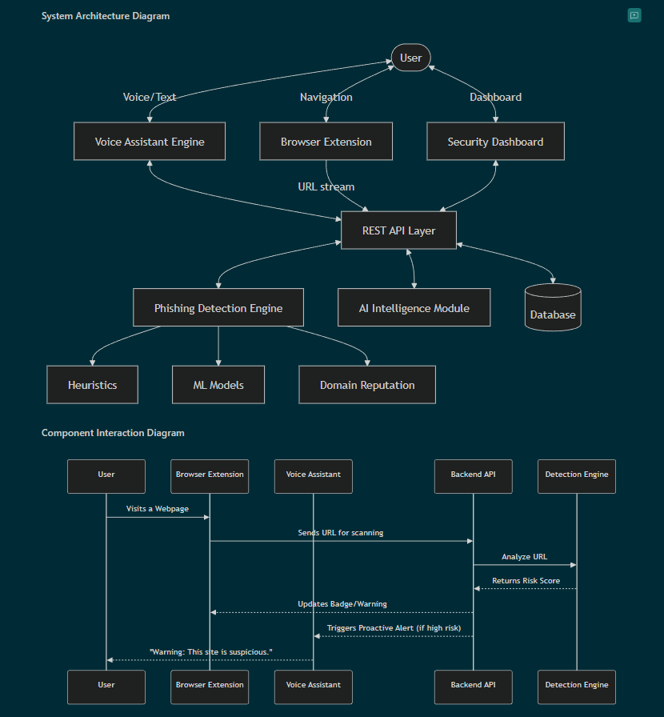

- Design and Implementation

The system was developed using a modular approach:

- Flask backend for API processing
- Chrome extension for real-time monitoring
- CORS-enabled integration
- AI chatbot for user assistance
- Dashboard for visualization

This design ensures scalability, maintainability, and efficient performance.

- Experimental Results

The system was evaluated using datasets of legitimate and phishing URLs. Results indicate that:
- Heuristic analysis effectively identifies suspicious URL patterns
- AI-assisted detection improves recognition of complex phishing attacks
- Real-time alerts enhance user protection

These findings align with prior research demonstrating the effectiveness of hybrid detection systems [7], [12].

- Limitations

- Dependence on heuristic rules for detection
- Limited use of fully trained ML models
- Browser-only environment restriction
- Possibility of false positives
- Scalability challenges with large datasets

- Conclusion and Future Work

This research presents a privacy-first browser-based phishing detection system integrating heuristic and AI-assisted techniques. The system enhances real-time protection, improves user awareness, and ensures privacy through localized processing.
Future work includes integrating advanced machine learning models, expanding browser compatibility, and improving detection accuracy against evolving phishing techniques.

- REFERENCES

[1] A. K. Jain and B. B. Gupta, “Phishing detection: Analysis of visual similarity based approaches,” Security and Communication Networks, vol. 2017, 2017.
[2] M. Aburrous, M. A. Hossain, K. Dahal, and F. Thabtah, “Intelligent phishing detection system for e-banking using fuzzy data mining,” Expert Systems with Applications, vol. 37, no. 12, pp. 7913–7921, 2010.
[3] S. Garera, N. Provos, M. Chew, and A. D. Rubin, “A framework for detection and measurement of phishing attacks,” in Proc. ACM Workshop on Recurring Malcode, 2007, pp. 1–8.
[4] N. Abdelhamid, A. Ayesh, and F. Thabtah, “Phishing detection based associative classification data mining,” Expert Systems with Applications, vol. 41, no. 13, pp. 5948–5959, 2014.
[5] J. Ma, L. K. Saul, S. Savage, and G. M. Voelker, “Beyond blacklists: Learning to detect malicious web sites from suspicious URLs,” in Proc. ACM SIGKDD, 2009, pp. 1245–1254.
[6] R. Verma and K. Dyer, “On the character of phishing URLs: Accurate and robust statistical learning classifiers,” in Proc. ACM Conf. Data and Application Security and Privacy, 2015, pp. 111–122.
[7] W. Zhang, X. Ding, Y. Tang, and Y. Luo, “Phishing detection based on deep learning,” IEEE Access, vol. 7, pp. 148347–148356, 2019.
[8] A. Le, A. Markopoulou, and M. Faloutsos, “PhishDef: URL names say it all,” in Proc. IEEE INFOCOM, 2011, pp. 191–195.
[9] Google, “Google Safe Browsing API documentation.” [Online]. Available: https://developers.google.com/safe-browsing
[10] Anti-Phishing Working Group (APWG), “Phishing activity trends report.” [Online]. Available: https://apwg.org
[11] Verizon, “Data breach investigations report (DBIR).” [Online]. Available: https://www.verizon.com/business/resources/reports/dbir/
[12] S. Marchal, J. Francois, R. State, and T. Engel, “PhishStorm: Detecting phishing with streaming analytics,” IEEE Trans. Netw. Service Manag., vol. 11, no. 4, pp. 458–471, 2014.
[13] D. K. McGrath and M. Gupta, “Behind phishing: An examination of phisher modus operandi,” in Proc. USENIX Workshop on Large-Scale Exploits and Emergent Threats, 2008.
[14] F. Toolan and J. Carthy, “Feature selection for spam and phishing detection,” in Proc. eCrime Researchers Summit, 2010.

